**NAME OF SCHOOL: ................................................................................**

**NAME OF CANDIDATE: ..........................................................................**

**INDEX NO: ..................................... SIGNATURE: ................................**

**535/3**

**PHYSICS**

**PAPER 3**

**JULY/AUGUST**

**2¼ HOURS**



**ELITE EXAMINATION BUREAU MOCK 2019**

**Uganda Certificate of Education**

**PHYSICS**

(Practical)

**PAPER 3**

2 HOURS 15 MINUTES

**INSTRUCTIONS TO CANDIDATES:**

* *Answer question 1 and one other question*
* *You are not allowed to start working with apparatus for the first 15 minutes.*
* *Marks are given mainly for a clear record of observations actually made, for their suitability accuracy and for the use made of them.*
* *Candidates are reminded to record their observations as soon as they are made.*
* *Whenever possible, candidates should put their observations and calculations in a suitable table drawn in advance.*
* *An account of the method of carrying out the experiment is not required.*
* *Mathematical tables are provided, silent non – programmable calculators may be used.*

**PART I:**

**Question 1:**

In this experiment, you will determine the constant K**1** of the spring provided.

(30 marks)

a) Set up the apparatus as below in the figure 1.

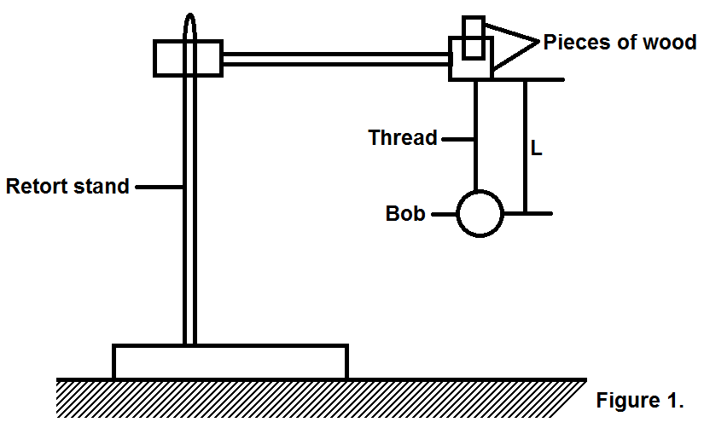

b) Measure and record the length **L**.

c) Pull the bob slightly towards you and release it to oscillate.

d) Measure and record the time, **t**, for 20 complete oscillations.

**PART II:**

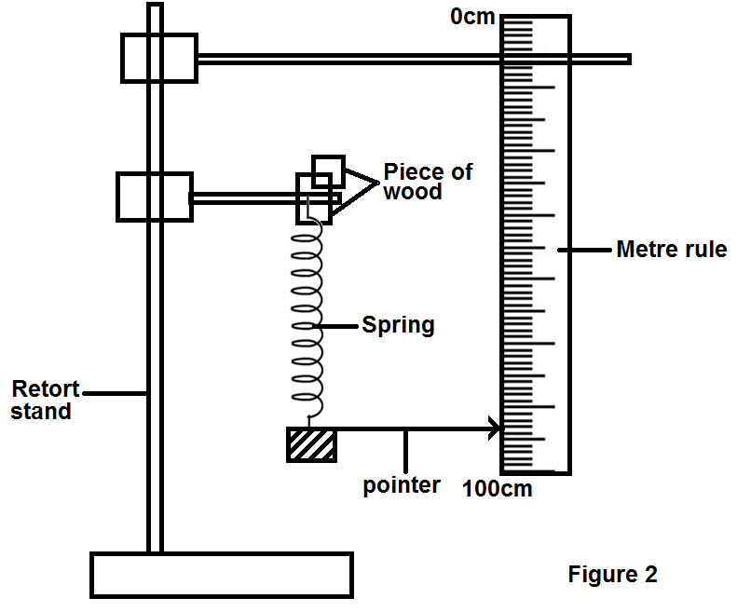

a) Clamp one end of the spring in the retort stand as shown in figure 2.

b) Read and record the initial position, Y**0**, of the pointer on the vertical metre rule scale placed with the zero mark at the top.

c) Attach and suspend a mass, m = 0.100kg from the lower hook of the spring.

d) Read and record the new position, Y**1**, of the pointer on the vertical metre rule scale.

e) Repeat procedures (c) to (d) for **M** = 0.200, 0.300, 0.400, 0.500 and 0.600kg.

f) Record your results in a suitable table including values of **Y** = (Y**1** – Y**0**) in metres.

g) Plot a graph of **M** (along the vertical axis) against **X** (along the horizontal axis)

h) Determine the slope, **S**, of the graph.

i) Calculate the constant, **K**, from the expression.

K = 1.6 x 10**3** 

Where t, is the time and L is the length of the thread.

**Question 2:**

In this experiment, you will determine the focal length f, of the lens provided.

(30 marks)

a) Mount the lens provided vertically onto a lens holder and focus the image of a distant object like a window onto the screen provided.

b) Measure and record the length, f, between the screen and the lens.

c) Connect the bulb, the dry cells and the switch k in series as shown in the figure 3 below.

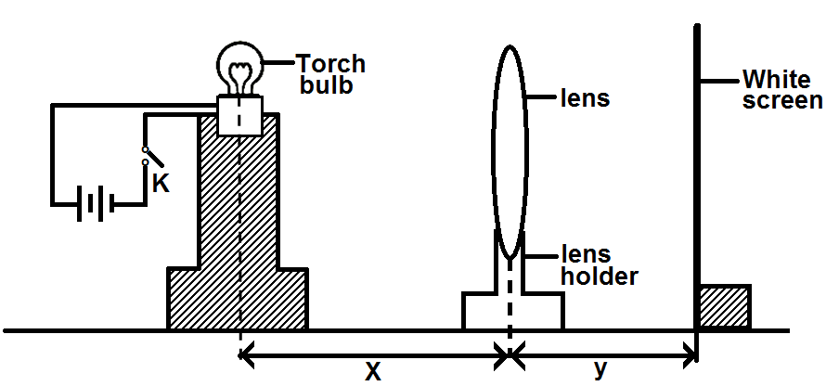

d) Arrange the bulb, the lens and the screen in a straight line as shown above.

e) Adjust distance X, between the bulb and the lens to 1.5f.

f) Close the switch, K.

g) Adjust the position of the screen to obtain a sharp and clear image of the filament on it.

h) Measure and record the distance Y, between the lens and screen.

i) Repeat procedures (e) to (h) for X = 2.0f, 2.5f, 3.0f and 4.0f.

j) Tabulate your results in a suitable table including values of xy and

(x + y)

k) Plot a graph of xy against (x + y)

l) Find the slope, f, of your graph.

**Question 3.**

In this experiment, you will determine the internal resistance, r, of the dry cell provided. (30 marks)

a) Fix the bare ware provided on a bench using cello tape.

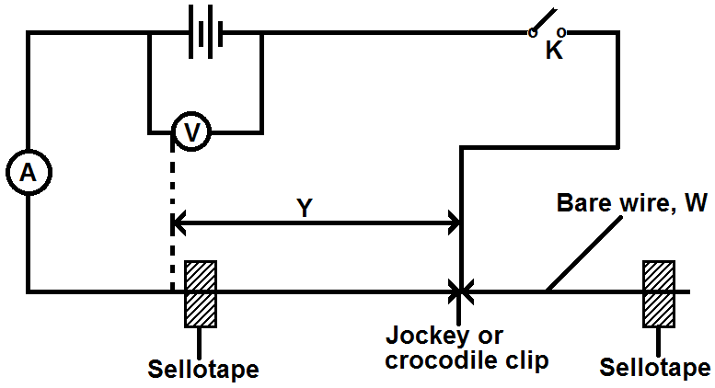

**C**

**C**

b) Connect the circuit shown in the figure 4 starting with y = 0.200m

c) Close switch K.

d) Record the readings I and V on the ammeter and voltmeter respectively.

e) Open switch K.

f) Repeat procedures (b) to (e) for values of Y = 0.300, 0.400, 0.500, 0.600 and 0.700m.

g) Record your results in a suitable table including values of 

h) Plot a graph of  against.

i) Find the intercept, C, on the axis.

j) Calculate the value of the internal resistance of the cells from the expression r = 1.5C.

**END**